WHAT WE LEARNED

* Engine wasn’t starting before because of incorrect power supply settings. We were plugged into the +6 V side but had the power supply’s setting on the +25 V COM side
* Base signal from current sensor (aka voltage when no current is flowing through) is related to how much voltage power we provide to the sensor

Vs = Vp/2

* + Vs = *signal* voltage from current sensor
  + Vp = voltage used to *power* current sensor
* Current sensor can be powered with more than the rated 8 V, but past 10 V, the zero-current signal is no longer half the provided power

THINGS TO NOTE

* Make sure the spark plug’s springs are attached to the spark plug before starting the engine

HYPOTHESIS

The current sensor likely works as follows: like most active elements, **the maximum voltage it can deliver is limited by the voltage it is supplied**. So if we provide 5 V relative to some ground to power the sensor, it can output a maximum of 5 V relative to that same ground. If it was a unidirectional sensor, it could simply map its maximum current reading of 100 A to the maximum voltage it can output, which in this case is also 5 V. Then 0 A would correspond to a signal of 0 V. However, because our current sensor is bidirectional, it needs to essentially split up the voltage range it can provide so that half the range corresponds to a positive voltage reading and half the range corresponds to a negative voltage reading. This is like having a voltage divider where R1 = R2 (=very small for a current sensor), and the supplied power to the voltage divider is the power you supply to the current sensor, 5 V.

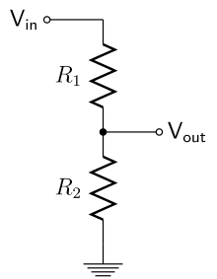

This means the the sensor’s *signal* is related to Vout. In essence, this makes the zero-current voltage reading half the supplied voltage, and then maps the maximum current it can read (100 A) to the supplied voltage. So for a supplied 5 V, the zero-current reading is 2.5 V, the 100 A reading is 5 V, and the -5 A reading is 0. **So the current sensor will never provide a negative voltage signal, making it ideal for reading it with an arduino.**